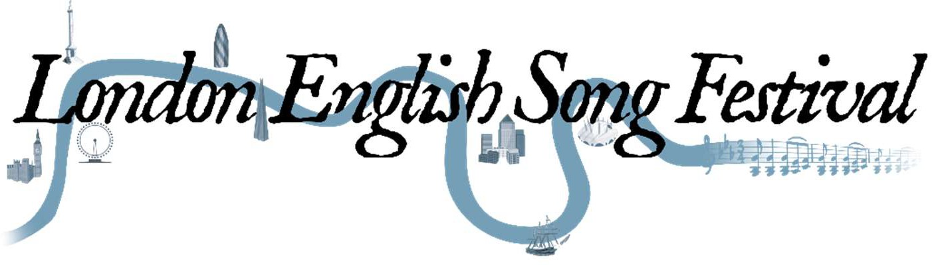

Judith 2019
Application and audition information

The London English Song Festival is looking for children with strong, unbroken voices to sing solo roles in a concert and recording of C Hubert H Parry's forgotten oratorio Judith.
Successful applicants will receive coaching from top professional musicians in advance of the concert and recording.
Concert: Wednesday 3 April 2019, Royal Festival Hall, London Recording: Thursday 25 - Saturday 27 April 2019, London Deadline for entries: Sunday 16 December 2018
Auditions will take place on Saturday 12 and Sunday 13 January 2018.
Entrants must be aged 9-14 (inclusive) on Wednesday 3 April 2019.
To apply:
Applicants must submit a recording and application form to admin@londonenglishsongfestival.org by Sunday 16 December 2018.
The recording must feature an excerpt of at least 30 seconds of a piece of the applicant’s choice. Recordings would ideally be submitted as emailed MP3 files, but Dropbox and private YouTube links will also be accepted.

